**Conversation Guide: Digital Health Modernization Discovery Research**

**Bold text identify the moderator’s questions.**

*Text in italics are Jen’s observations and interpretations of the participant.*

[Text in brackets are interpretations in participants’ direct quote.]

**Background (5 minutes)**

To get started, I’d like to get a little background information about you, and your experience with the VA.

1. **Can you tell me a little bit about yourself?**

My name is Erick Holmes I live in Norwich CT, I did Army National Guard for 9 years and the last 3 were on state active duty.

I currently work at the US naval subbase that is in Groton CT.

I live with my girlfriend and her daughter.

I work as a material handler.

1. **When did you leave the military?**

April 29th, 2011.

1. **What VA benefits do you receive?**

As in care or prescriptions?

**I understand you have VA healthcare, is that right?**

Yes

**Do you have anything outside of healthcare that you receive from the VA?**

*Participant has to think about it for several seconds*

Uhhhhhhhh, actually no I don’t, just healthcare.

**VA housing benefits?**

No, no, the house I have in CT had a first time home buyers that was better than the VA so I used that.

**Education or GI Bill benefits?**

No I can’t. With my DD2-14 since I was on state active duty it is a little bit different than federal active duty.

**Filed disability claim?**

Yes. I am in the process of trying increase and file new ones as we speak.

**Disability currently?**

Yes.

1. **Do you have any family members who you claim as dependents?**

No dependents unless you consider dogs.

1. **Do you manage any of your VA benefits online?**

Some stuff, if I need to get ahold of my doctors real quick I don’t want to come in but this is what is going on.

I also get my multi-vitamins as well. *Audio broke up a bit* prescription give it about a day or two. So I talk to them on that.

**5.a. Where do you do that?**

The VA one. I call it the normal one but it’s my HealtheVet I think it’s called.

**Anything else:**

No right now I don’t have a regular doctor in the town because they are not taking new patients.

**All providers through the VA:**

Yeah for right now. I would like to get a, I call it a homegrown doctor, but an in town doctor because I cannot always make it to the VA.

It really depends and right now I don’t think they are in the office because of COVID so unless it’s something you really have to go in for they are probably going to refer you to hospitals farther away.

**Apply online:**

My first initial one was through an advocate to start it and submitted it and provided me a copy. The second was all online.

**How did you get connected to the advocate:**

Other vets in the area that I work with.

**Website:**

Same one I use for secure messaging - my HealtheVet.

1. **Do you use any mobile apps to manage your health?**

No. It is all done on a regular computer, I try not to keep to many apps on my phone.

**Any particular reason:**

With all of things being hacked. I work for the government, that got hacked into. Other peoples credit cards.

I’ve got more identity theft programs to last me forever so I try to keep stuff to a minimum.

**Mental model of health at the VA (20 minutes)**

Now I’d like to hear about your experience transitioning from the military to the VA. **(10 minutes)**

1. **How did you learn about the health care available to you through the VA, and what was the process of applying for and accessing those benefits?**

Basically coffee chitchat time at work, the topic was brought up “oh yeah I have this problem” and you should go there. I never went overseas and didn’t want to take advantage.

I doesn’t matter if you went overseas. You got injured. If there is something wrong that was caused by the military, you need to make the claim.

The worst thing you that can happen is they say no. You don’t know until you try and that’s how it came about.

**Did you know prior:**

Thought had to have gone overseas. I did all mine stateside.

I didn’t want people to think I am scamming the system because I didn’t go overseas.

Talking to other vets they said - the military causes injuries you should possibly be compensated.

**Did healthcare or disability come first:**

*Participant sighs and has to think about it for several seconds.*

I filed in 2015, February or March and got approved Sept/October 2015.

They will get the claim and not hear form them until you have a, I think a C&P exam, something where they can physical see what is going on.

Once that is through it was about 1-1.5 months after that you were granted for 10% for the bunion, 10% for tinnitus, then 0% for razor bumps.

So I got 20% percent overall but the two 0 percent’s I can still can get seen for.

**Did breakdown of percentage explain what healthcare you get:**

They told me if you are 10% you can be seen for pretty much anything, either 10 or 20 you can get seen for anything such as a cold or back ache.

Under a certain percentage you can only get seen for that issue.

1. **Tell me about the health care you receive through the VA.**

*Participant chuckles at the question.*

It’s okay. Honestly, I still feel like if I am in basic training where they get you in and then get you out. It sounds like they care and try to do what they need to but it all seems rushed.

A lot of veterans say I talked to the same thing. They try to fix what’s going on but then try to get you in and get you out.

I am not talking about all doctors but the ones I have seen seem under too much stress to get patients in and out.

So it’s okay.

**I remember you saying you want an intown doctor because of that:**

Yeah. Eventually.

**Is that of them trying to get you in and out:**

Yeah. It’s not on everything that you go to the doctor for but it is a lot of things. I get it that they are stressed and have a lot of patients, if you can go intown quickly instead of going there I can see it.

I would rather have two so I can be seen quick rather than trying to go through the process of going to another town to the VA and dealing with a lot of others that need to be seen as well.

**2.a. (If they have dependents) How do you manage your dependent’s health care?**

1. **Do you use any medical providers outside the VA for any of your health care needs?**

No I can’t because they aren’t accepting new patients then COVID hit so that’s adds another issue to it.

1. **Since you first became a Veteran, has there been a change in the types of VA benefits you’ve received?**

I don’t know what really is available.

I know the VA loan but I have my house. I don’t know if there’s other types.

I know there’s education benefits but again there’s a code that separates federal active duty and state active duty benefits. So I don’t qualify for a lot of the federal benefits.

I found out yesterday that they passed a bill a couple years ago are able to do dental services and it expires December of next year. Man, I could have used that.

**How do you learn about what you can have:**

Going on the website my HealtheVet and browsing around when you have time to see the new things.

I am signed up for the VA email service, it has nothing to do with the VA itself. It’s just a website to find out all kinds of discounts and about other programs and people ask questions and respond.

So I do a lot of google searching.

1. **How would you explain a “disability rating” to a new Veteran?**

I tell the guys I work with at the Navy sub-base that are starting the process or about to start the process of discharge.

I tell them if they have any issues going on to start seeing the doctor to get it in your file. You injured your back 10 months ago and its fine now but you need to see the doctor on everything and have it on your file.

I explain when you start to get out or get out you need to file a claim if it happened on active duty. The worst thing is that they say no but if you don’t say anything how is anyone supposed to know and how it is supposed to get fixed.

Because once you leave your done.

**What do you explain what it impacts:**

Other veterans I talked to said 30% is your goal. Especially if you’re trying to hire for a job, but it puts you at the top.

That’s what I tell them, it’s a rough world out there, any advantage you can get. It’s a legal advantage. Your rating determines your other benefits you’ll get. You may not know 10 years from now you may not have a pot to piss at least if you can get some of your benefits started now.

You see a lot of veterans that don’t have anywhere to do anything, but they wish they would have made a claim.

1. **In your mind, is there a relationship between “disability” and “health care”?**

Yeah, I guess the more disability you have thebetter healthcare you could get later on. Especially now the world we live in is unpredictable so you have to look out for yourself. This is your health and wellbeing you need to follow up on it.

1. **When it comes to your health care, what is the most important thing you need from the VA?**

Understanding, suggestions, maybe put themselves in my shoes. They sounds like they care but take the extra time to ask the extra questions, or when you say you will do a follow up, make sure you actually do the follow up. Give someone a call or email them.

**Do you feel like your getting that now:**

My doctor that I had, he just retired, he used to do that. I feel the only time they will call, or have their secretary or their nurse call, is about an appointment coming up.

Now I’d like to ask you how you manage information and tasks related to your health care. For each one, talk me through the steps you’d take. If there is something that you go online to complete, I may ask you to share your screen so I can see what you would do. **(10 minutes)**

**Tasks** Moderator should prompt about device usage if participant mentions digital tools or resources.

* **How would you reach out to your VA care team if you had a question?**

I would go on the website my HealtheVet and drop a secure message to my doctor. It would end up going, even though it says it’s going to the doctor, it would go either to the nurse on call or the secretary nurse then it would go to my doctor to reach out to me.

*Moderator prompts to share screen.*

I would type in my HealtheVet. I don’t have it saved.

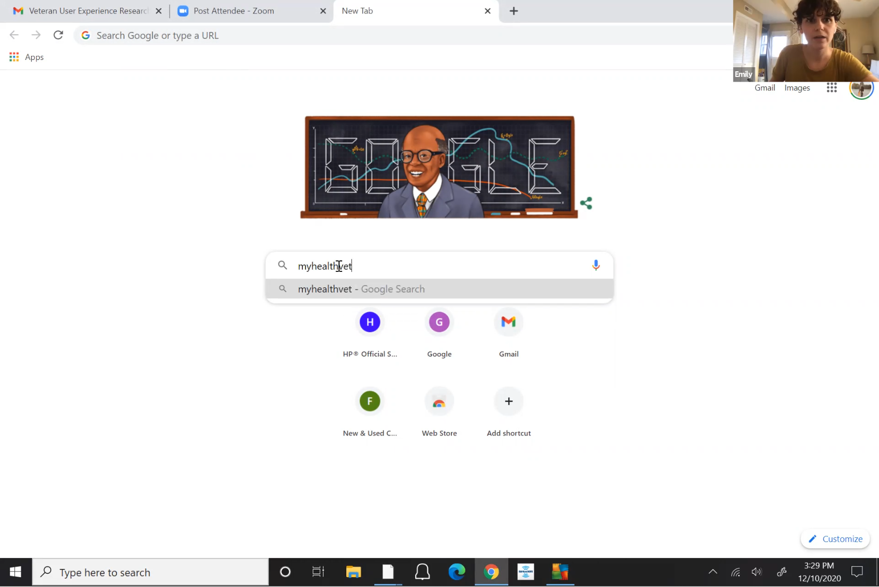

*Participant enters “myhealthvet” into search bar of Chrome start page.*

*Are you on a laptop?*

I’m on a Microsoft Surface tablet.

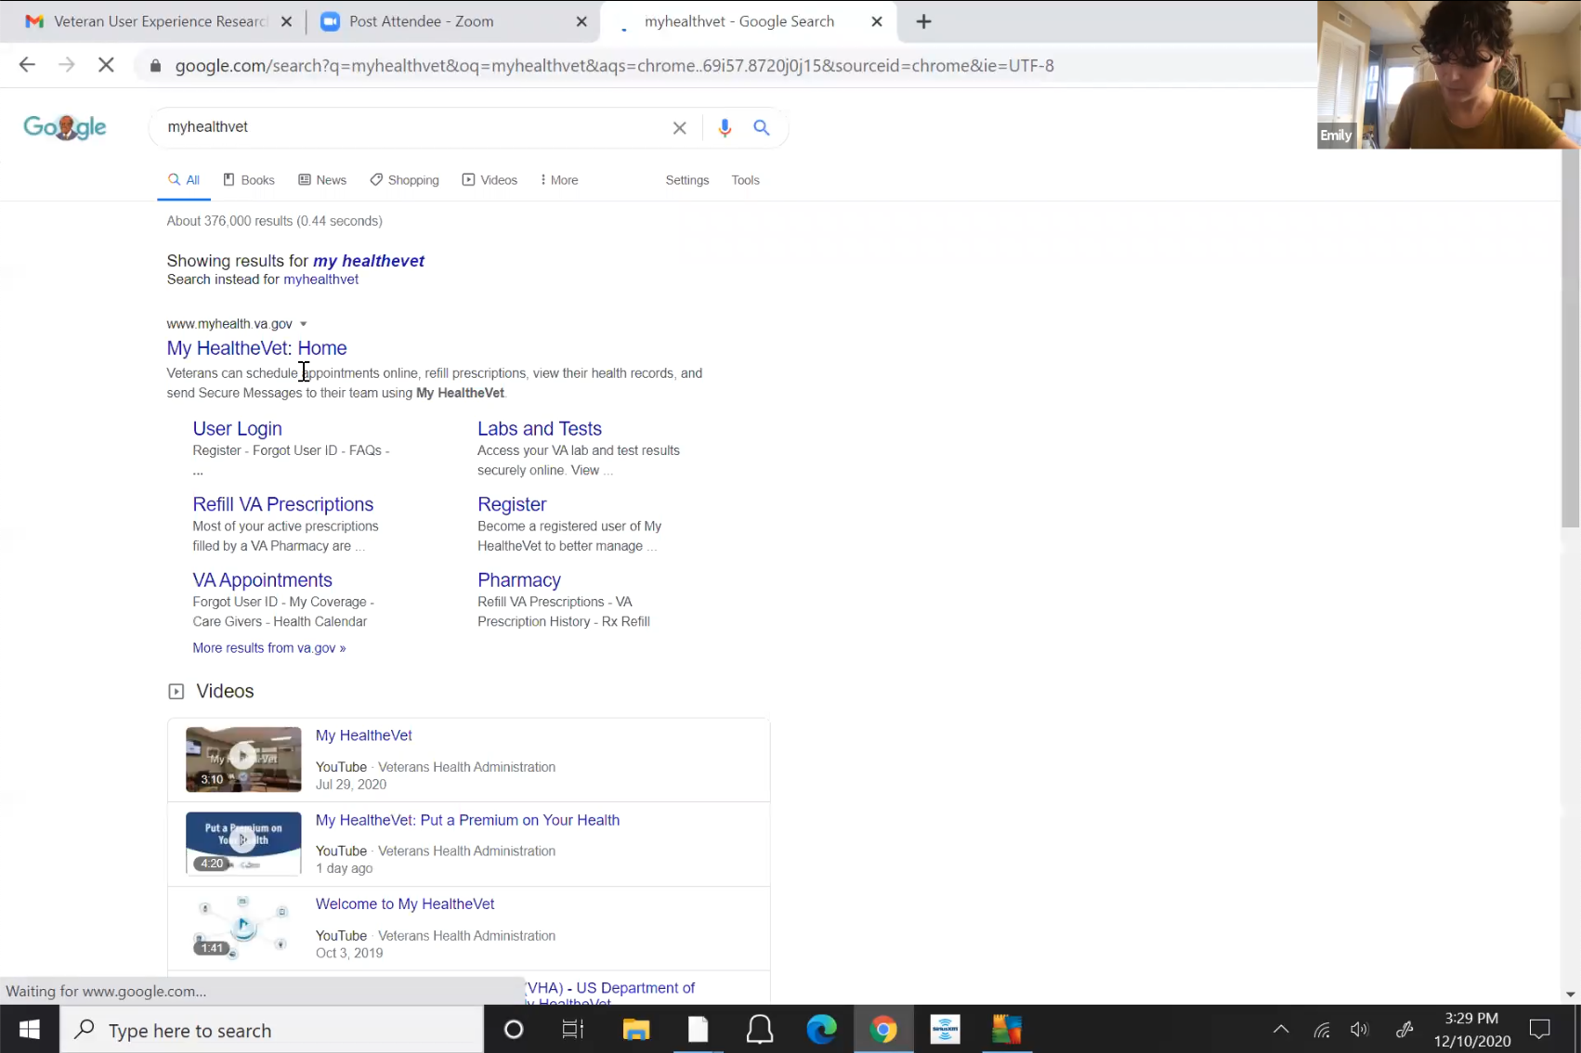

*Participant opens My HealtheVet website from Google search page. Participant asks if moderator wants them to sign in. Moderator says yes.*

* **Why isn’t the website saved:**

Just lazy. I don’t go on ask much at home versus when at work.

* **Why pick** [ID.me](http://ID.me) **login:**

I remember that one when I am at home, when I am at work I use my CAC card.

They do have really good deals a lot just to let you know. ID.me is a really good website for deals on products and try to get the best deal for anyone that signed up. It is not just for veterans, it is for doctors, nurses, and teachers as well. They ask questions to verify then each week you get emails on the discounts each week.

*Participants goes through process of signing into [id.me](http://id.me) via 2F authentication while talking about the above deals.*

I would go to compose a message.

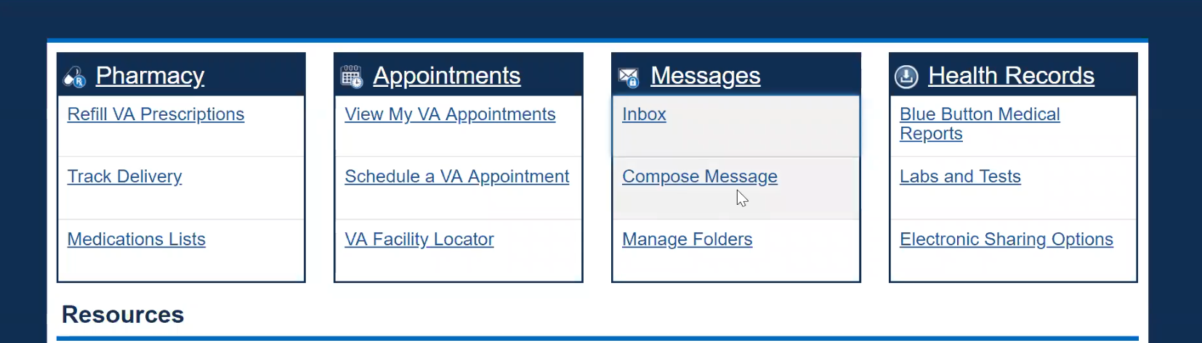

*Participant clicks Compose Message in Messages box on home page.*

*Secure message page loads.*

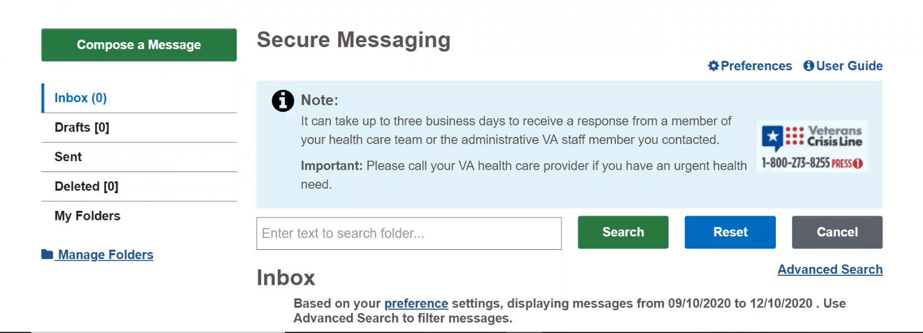

*Participant looks at screen for several seconds.*

I know there is a compose button.

It used to say composed. I don’t see it. I forget where.

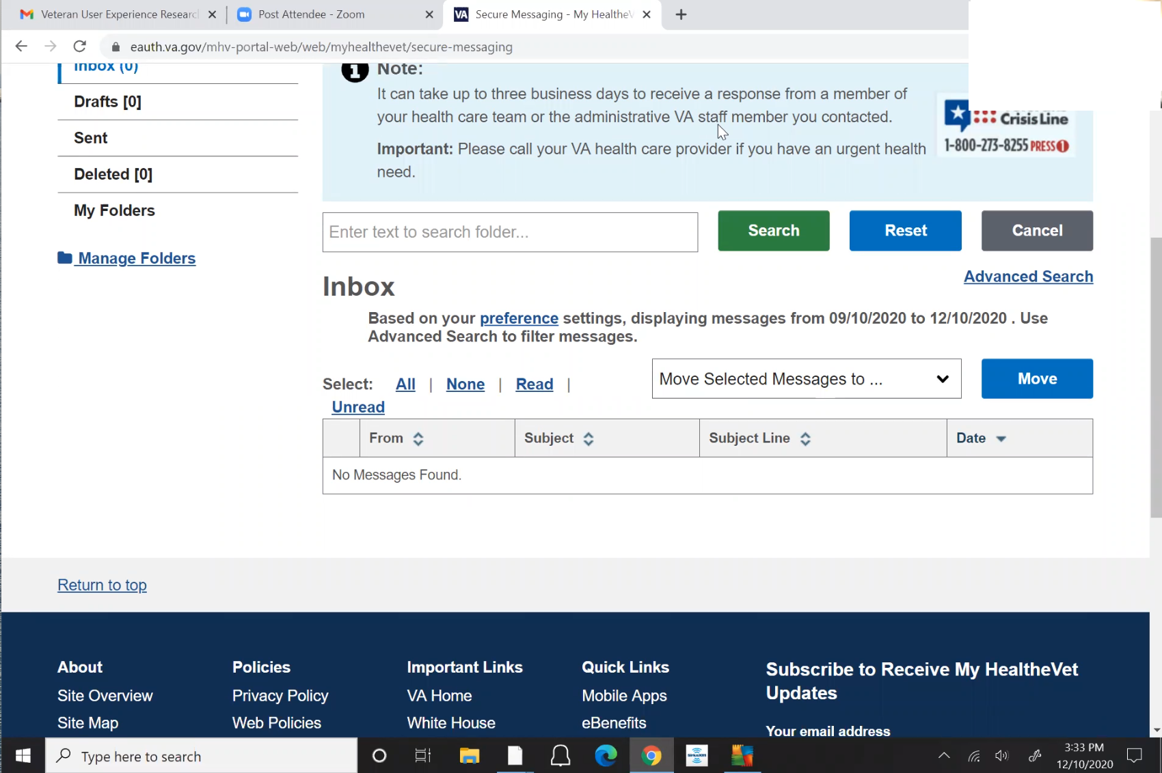

*Participant looks at screen for several more seconds and then scrolls down page seeming to focus on Inbox section of page. Green Compose a Message button is no longer visible.*

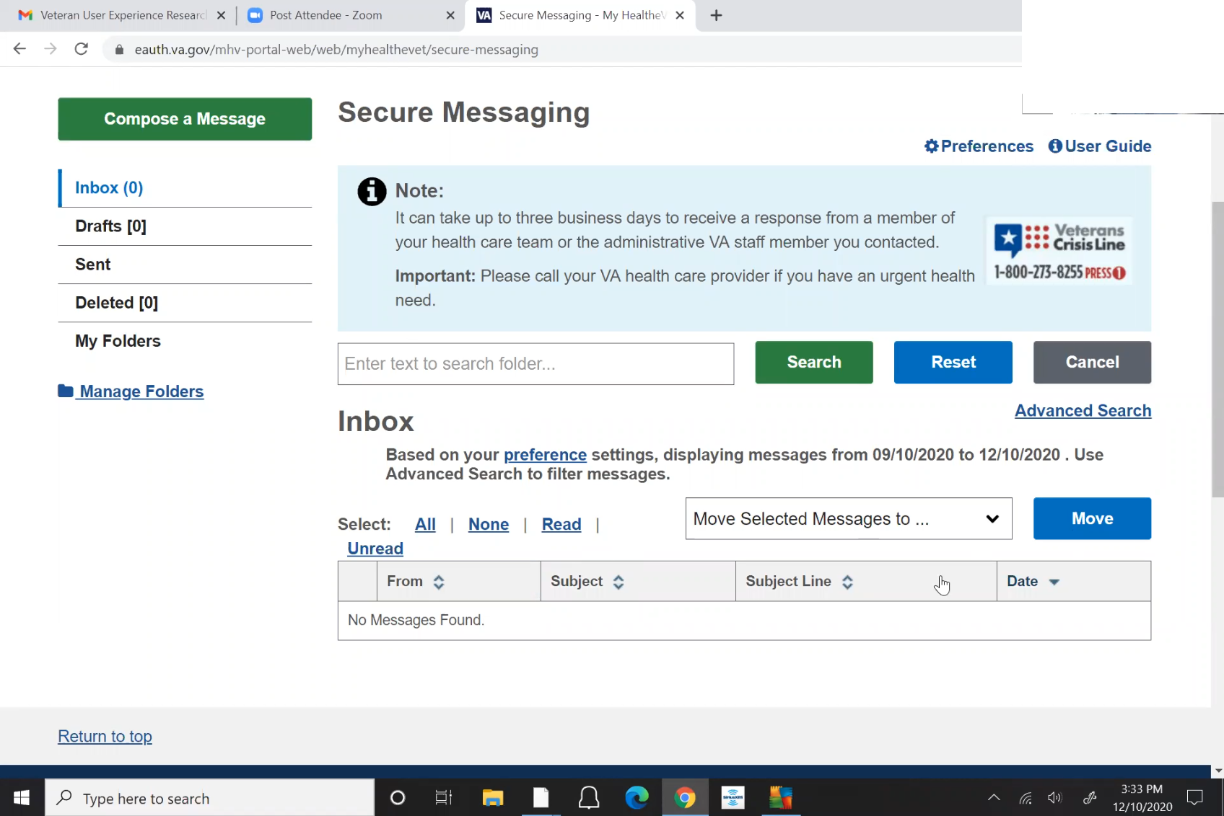

*Participant starts quietly reading link text to themselves and scrolls page back up. Green Compose a Message button is visible again. Several more seconds go by.*

Oh there it is. Sitting right in front of me I’m sorry. *Participant chuckles.* Man it’s been a long day.

I would go to compose the message, and then you are able to pick down what team or doctor you need. Then this gives you everyone that you can email. Either the department or certain doctor.

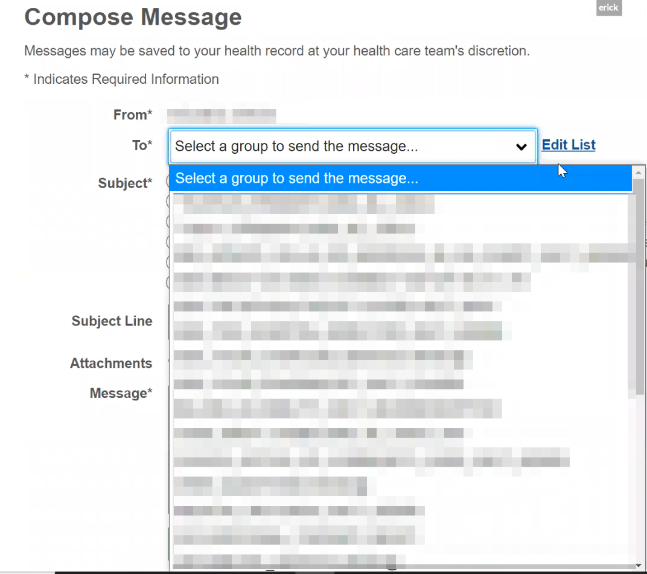

*Participant clicks on Compose a Message button, and shows To: dropdown options in message.*

* **It goes to the doctor but nurse sees it first:**

Yes, I don’t know. Maybe giving them a heads up about the email they will get to see if they approve or not.

* **Do you see the back and forth. How did you learn about the communication chain:**

I did this last year sometime. One conversation I had with the nurse, they said no it goes to us first, we look to get an idea of what is happening and send it to the doctor. He or she [doctor] already has a heads up but they actually read it to make sure they didn’t miss anything. We [nurse] monitor it but we don’t monitor it type of thing. *Sounded like the nurse monitors communication but doctor has review and input.*

* **How would you refill a prescription you have with the VA?**

The same thing click pharmacy and click refill VA prescription

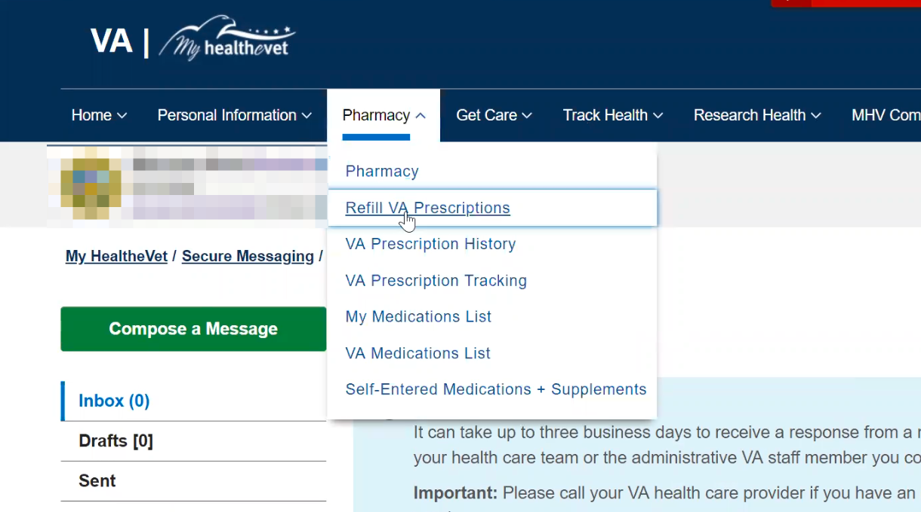

*Participant hovers over Pharmacy in main navigation and clicks on Refill VA Prescriptions link in drop now navigation.*

* **Is this your primary method for refilling prescriptions:**

Yes if I need something. I would go on here then just click or put a checkmark or cover that there. *Participant checks checkboxes for individual prescriptions demonstrating how it works.*

If I’m able to say I need a refill then wait about a week. Within a day or so they’ll have some kind of message of the side VA prescription tracking. Sometimes they have a little information or through USPS I would get a tracking number.

* **Is the USPS tracking number you see here or a separate:**

Separate email because I signed up for USPS anything piece of mail is coming to the house they show a scan of it, shows tracking number, and where it’s coming from, and I know it is my prescriptions.

* **How would you go about checking the date of an upcoming medical exam you have for a disability claim?**

I just had one a few weeks ago. Since the VA is overwhelmed with new claims and COVID they gave it to a third party QTC, a third party company. They reach out to the person that needs the appointment.

The problem was it took a couple months because it goes by where you live and how far you want to travel. At the time the closest one was in MA and NY. NY is not doing so well with COVID so I went to MA. You don’t want to keep saying no because you fell like it may hurt your chances of getting the claim and then you grin and bear it and go to the “closet one to you”.

* **How did they communicate :**

They emailed and called. A lot of times I don’t do calls because I can’t hear too. I have tinnitus so I have ringing. I like to do it all by written forms but the email is proof.

They did both. I started that I want to do email but they still need verbal confirmation so they will do both.

If you miss the call they provide a number to call back and then go from there.

* **Email was there anything online to do:**

Yeah, when you do the verbal confirmation, then give it a few minutes and then they send you an email that you need to register. This way you put a username and password and sign in with that. Then it has all of your information you need to go to your appointment. Such as the time, doctor you’re seeing, map to it.

Within a week using FedEx they send the same a packet with the same information except for registering online. Then on a paper you list everything wrong for everything you need done and then you fill it out a survey to complete after you see the doctor in a self paid envelope.

But it is always comes in a FedEx packet.

* **Would you expect to see the date of that exam on this website anywhere:**

No because it’s a third party.

It is the same thing when you’re trying to get your results. I may take longer for your records for that because it is a third party.

* How about an appointment for a yearly check up with your VA care team?
* (If applicable) Or a private provider (dentist, optometrist) outside the VA?
* **How would you pay a VA health care bill, such as a copay?**

Not so much a co-pay just a couple dollars for certain prescriptions that my regular Blue Cross Blue Shield through work didn’t pick up.

* **How do you pay it:**

The bill comes in the mail. Because you don’t know until you get one.

They have is va.gov/pay. Something, its a website made for payments to the government or the VA. And then you just go on there. There’s a code or client id, you type the client id, and it already knows how much you owe. Then it asks you how much you want to pay, either full or another amount. You put in the bank or credit card information. Then you receive a confirmation email.

* **How would you request reimbursement from the VA for traveling to your health care appointments?**

I have, they are very picky on it. So if it is related to what your disability is they will pay you for, but other stuff they won’t pay you.

* **What was the process:**

There’s a couple ways. When you go to your appointment there’s a kiosk that asks you are you here for this appointment, then in that system it knows if it is related to your disability, and it asked how you got here, did you travel by car, train, by friend. And then later on a few weeks later you get a check or your travel claim was denied.

I think you can do it on myhealthevet, I’m not quite sure, but I usually go when I sign in I just take care of it then and there.

* How would you update the dependents on your VA benefits?
* How would you make updates to your health care benefits?

**Branding and trust (5 minutes)**

Now I’d like to ask for your thoughts on My HealtheVet. (Confirm that participant has used My HealtheVet previously. If not, amend questions below to capture their first impressions while looking at a logged in account.)

1. **How would you describe My HealtheVet to a fellow Veteran?** Complicated but easy. It’s very easy to use but very complicated at the same time, because your question may not fit in one of these categories - either pharmacy or get care or track health or so on. *Participant is still sharing screen and seems to be reading off items in main navigation of My HeatheVet website that is still open.*

So overall it’s easy because you can get to where you need to but can be difficult because you do not need an immediate response but you need a response, and you don’t know what numbers you need to go. Especially if you’re trying to get a new claim, and you need to go through a different set of numbers and email to get that started.

1. **You called this website the normal one, why:**

It’s my go to for anything. Even though I could most likely call but choose not to.

I would rather send an email. If it didn’t pertain to them they tell me it doesn’t.

But if you call the 888 number they will get you through whatever.

1. **What about “VA health care?”**

*Participant chuckles.* Uhhhhhh. *Participant chuckles again.* Hmmm. It’s tough. I would say it’s worth the time but don’t get easily frustrated.

Reason being is that you have to take in consideration that they are overworked and possibly under paid because of the amount of veterans that need care. But you need to be patient because if there’s something that happened to you while in the military, this is the first process to do it.

I say to them once you are in it is great because you are able to go to an outside source [private care] and the VA pays for it. But all your medical information gets interlocked together.

Urgent care that they did I really appreciate.

You don’t have to clog up your doctor because you have a sniffle or a see or whatever, but all of the information eventually is sent back to the VA.

It is easy but more of wiggle your toes and stay in line.

1. **On a scale from 1-5, with 1 being very dissatisfied, and 5 being very satisfied, how satisfied are you with My HealtheVet:**

Ahhhh. *Participant thinks for a few seconds.* I would say a 4 because the purpose I need it. I don’t have a problem on it.

I’m sure there are ways to improve, I don’t know what, but I only use it for a few things.

If you ask another vets that uses it all day everyday they may give more reasons.

For me it’s a good solid 4, easily. For what I need to do, I see it and we go from there.

3.a. **What makes you rate it a [their rating]?**

What would make it better? Maybe if they were able put the trackable stuff be able to chat with someone online.

Like live chat why I can’t get education benefits then provide the reason why.

They have talk ask other questions, why it’s taking so long.

Talking on the phone it could take an hour then if they accidentally hang up you have to start all over.

1. **On a scale from 1-5, with 1 being very low, and 5 being very high, how would you rate your trust in My HealtheVet?**

*Participant thinks for a few moments.* Umm. Well right now I’ll give it a 2 because I am still waiting on the doctors notes that they haven’t transferred over.

The doctor I saw last month, that information is in there. How long does it really take to put in information to where I can retrieve it.

I don’t know if it is all of the information that’s in there. They may have the final say on what does in and doesn’t.

1. **Where do you find them [doctors notes]:**

I would have to go to.. *Participant looks at website for several seconds, quietly says “track health” to self and hovers over Track Health menu item in main navigation. Participant then mouses over Track Health menu item and submenu appears.*

Between either track health or health history. *Participant hovers over Health History in submenu dropdown. Participant then stays hovered over Health History and thinks for several seconds. Participant clicks Health History link.*

Oh nope that’s the wrong one. So it would beee…

*Participant hovers over Track Health menu item, submenu appears, and they say “vitals, oh” quietly.*

So I usually do it, there’s a couple ways I do it. If I don’t do it through Health History and don’t find what I am looking for, I got to Labs and Test.

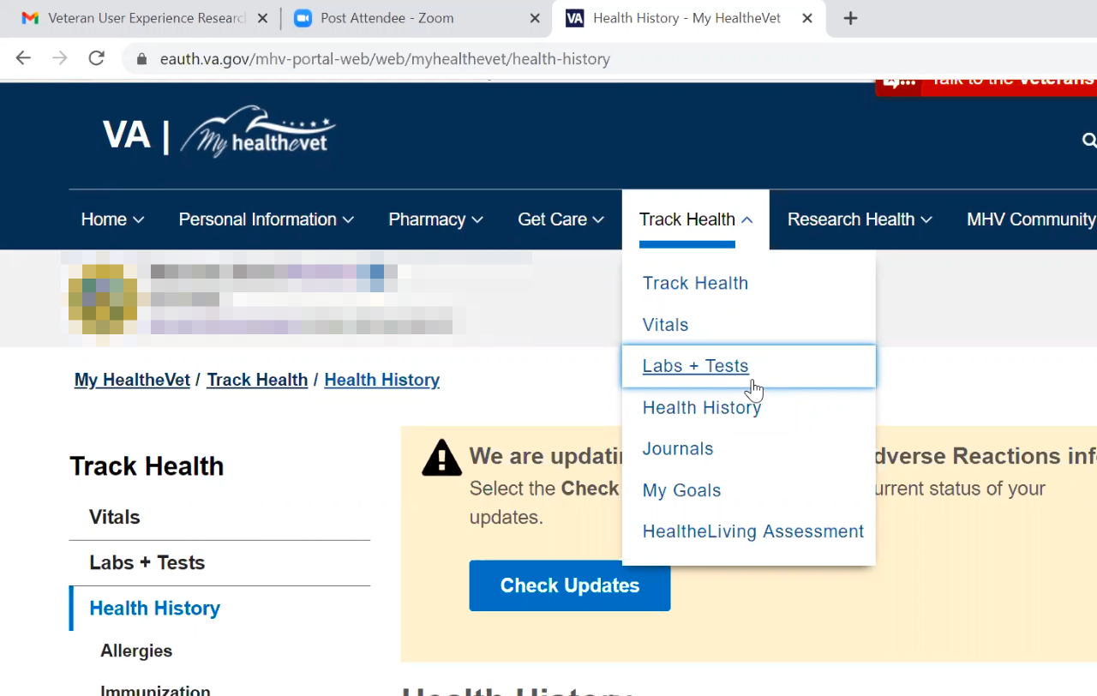

*Participant hovers over Labs + Tests in submenu navigation but doesn’t click link.*

It should come down to the blue button and you can download all your information.

1. **Where to get additional resources/information:**

I want to say this is the good one, the My HealtheVet community, and any of these will lead into something that will lead into something else depending on what you’re looking for. It is the chain reaction.

That is where I found out, I forget where in here, about dental for a reasonable cost but it ends next year.

1. **Mentioned you get an email newsletter outside of the VA, click on subscribe, have you seen this:**

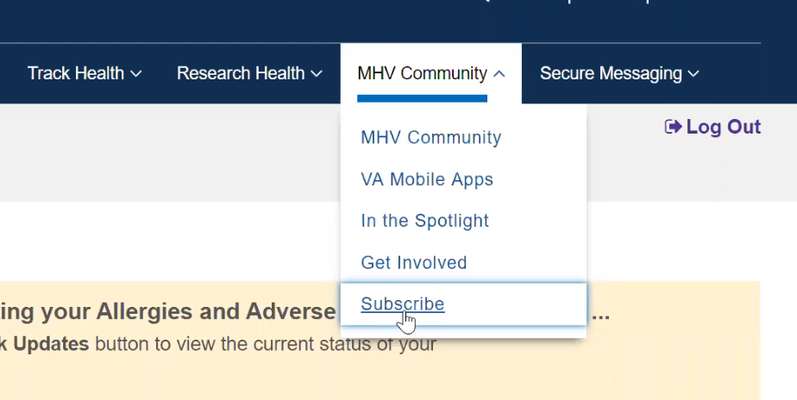

*Moderator directs participant to hover over MHV Community in main navigation to show where Subscribe link is. Participant hovers over link and clicks.*

*Participant looks at and scrolls through Subscribe page.*

I think that is one of them I get if I am not mistaken.

I just got one in not to long, but I ended up deleting it because I didn’t need it.

I see this a lot. *Still looking at and scrolling up and down on Subscribe page.*

I know the VA started their newsletter again or started again, and it finally comes through. That’s how I found out about [ID.me](http://ID.me) or sometimes from the same company, [ashleyid.com](http://ashleyid.com). That’s how I learned about stuff, clicking on the email.

**My HealtheVet patient portal (15 minutes)**

Let's take a look at My HealtheVet together.

Moderator will ask participant to share screen if not already, or show logged in My HealtheVet account. **(5 minutes)**

1. **What do you use this website for the most?**

To send my doctor a note or ask for an appointment, refill prescription, or make appointment.

1. **What do you find the most valuable on this website?**

For me all of those are at my fingertips and it saves me from calling.

Some people prefer to call, I prefer things in writing so I don’t need to ask all the time. Huh, I can’t quite hear that. Say that again. *Participant was reenacting how they talk when on the phone and can’t hear.*

I’m sure it would be annoying for the person that has to repeat it so all of those things work the greatest.

1. **What do you wish this website did that it doesn’t do right now?**

The live chat where they can chat about whatever, then if its to much to chat they provide their direct line you can give me a call and we’ll look into it farther. Live chat to, if it is okay to call or video chat with you for, not heatlh, whatever questions they are looking for. It is easier then click her and here rather than typing it out.

(If time allows) While we're here, I’d like to get your feedback on a couple of sections on this website. **(10 minutes)**

1. **Va.gov, did you see this before:**

That sounds familiar.

*Participant opens a new tab in Chrome and types in “[va.gov](http://va.gov)" in address bar. Connection is slow on Zoom so hard to tell if participant clicks on anything. Page goes blank and address bar says it’s trying to load [api.va.gov](http://api.va.gov). 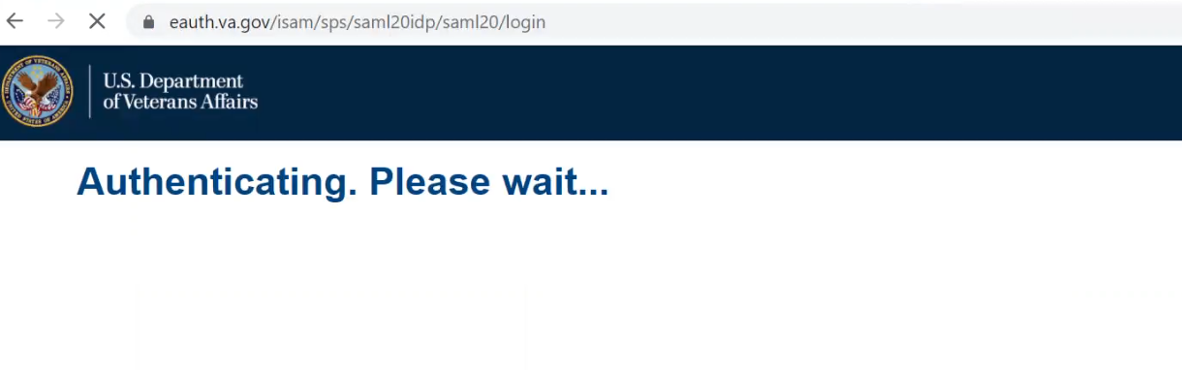*

*Screen changes to show “Authenticating. Please wait…” status message. Participant gets confused about where they are at. Says to self “*did I subscribe? Opps*” and clicks back to tab open to the MHV Subscribe page.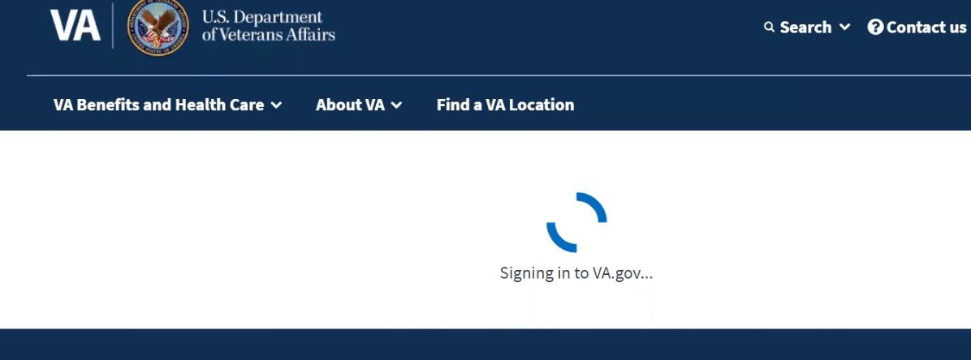*

*Clicks back to [va.gov](http://va.gov) tab where there is a loading/wait icon and message “Signing in to [VA.gov](http://VA.gov)".*

It must auto sign you in.

Yes, I did that first before I had my HealtheVet. Once I got the website to myhealthevet I have it bookmarked versus going through this.

**Both pages bookmarked at work:**

Both are marked at work here at home I just google search it.

This is how I did my second claim. That’s how I started going about submitting a claim.

**Thank you and closing (2 minutes)**

**Any additional feedback or questions?**

No you answered all mine that I was thinking off.

**Any other feedback:**

You got everything that I should have. Hopefully they’ll improve it. It’s always going to be an ongoing process on how to improve it.

**Other vets who might be interested: -**

I tell them all the time. They want information from veterans and their trying to work to improve things. It’s a good survey. Plus you get paid for it. But the main thing is to say what you need to say without feeling that it’s going to hurt you and the VA. From what I gather you guys are a third party and you have something to do with the VA and you’re not really affiliated.

Yeah I say I love doing these. Plus you can vent with in reason. And you just hope they take what you’re saying into consideration.

So yeah I tell them all the time.